Problem 1:

1a) In a magnetic B field of the form a projectile is launched fromwith velocityThe following is a plot of this particle's trajectory using a second order algorithm of time step of 0.04, 0.02, and 0.01.
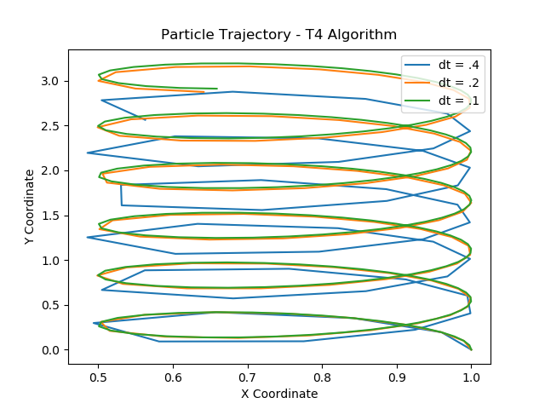
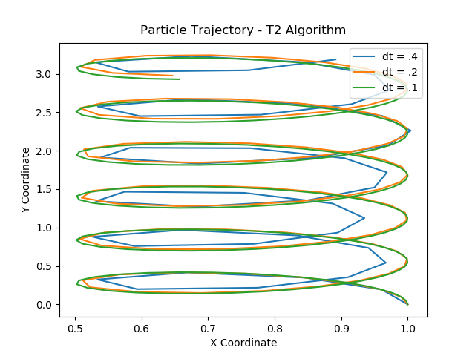
1b) The same trajectories, but using a T4, Forest Ruth algorithm.

Problem 2:

2a) For the given parameters, we compare the trajectories of a 1st and 2nd order algorithm with the theoretical calculation of a damped harmonic oscillator using a time-step of 0.9 (a large time-step so we may actually see the difference between theory and the 2nd order):
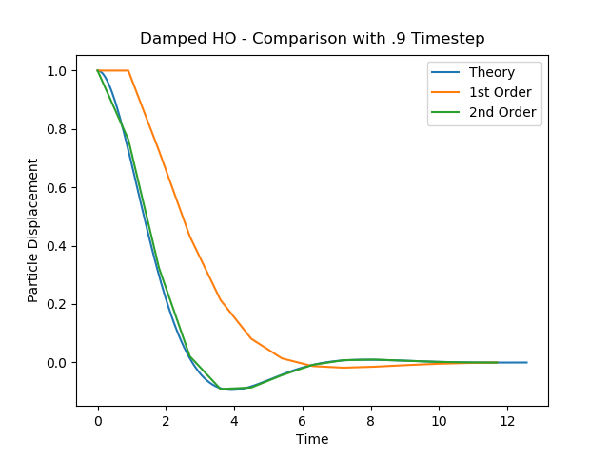
How would you measure the error in this case when we do not have a Hamiltonian?

Since we have already calculated the theoretical value as a function of time, we would simply invoke the following formula:

2b) Solving again using a 4th order algorithm:

